**Class 2**

**Comparative Advantage and Trade**

**Absolute Advantage**: produce more of a good or service than competitors, using the same amount of resources.

**Comparative Advantage**: produce a good or a service at a lower opportunity cost than competitors.

* Comparative advantage is the basis of trade.

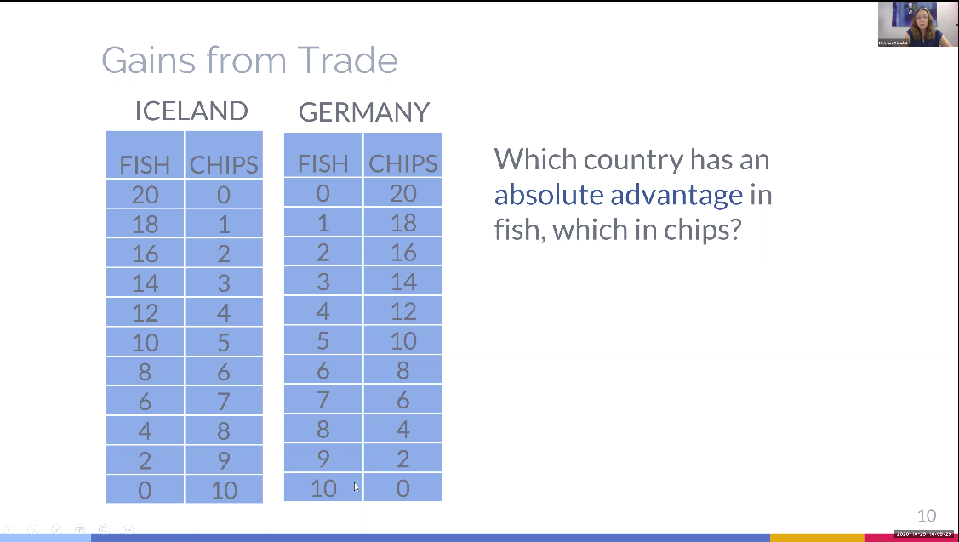

Iceland has an absolute advantage in fish, because Iceland can produce 20 but Germany can only produce 10. Germany has an absolute advantage in chips, because Germany can produce 20 but Iceland can only produce 10.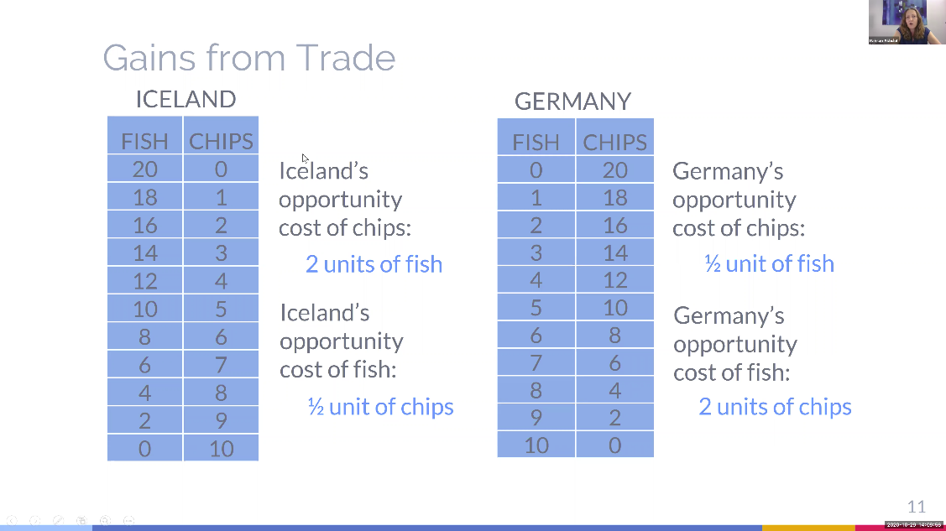

My understanding: Iceland should produce just fish and Germany should produce just chips.

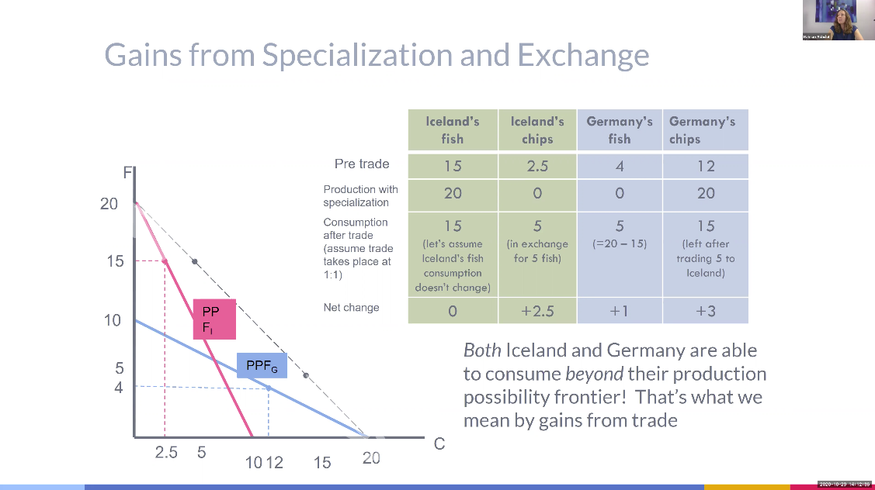

My understanding:

If two countries produce absolute advantage produce and then trade it, both countries will benefit.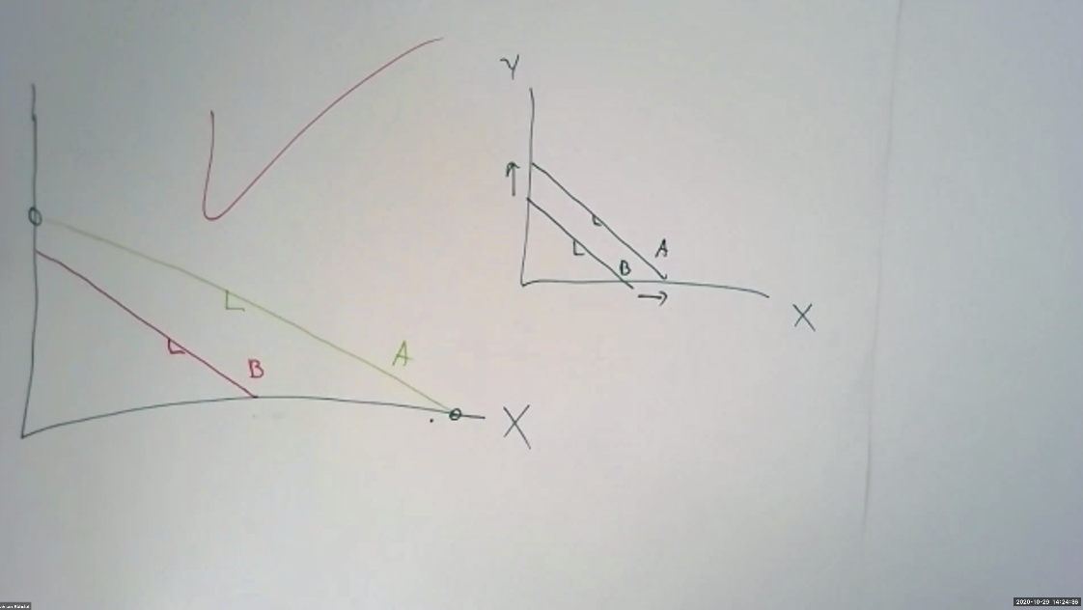

My understanding:

The picture on the left, country A has absolute advantage in both produce X and Y, but slope of two lines are different, so they have different opportunity cost of X and Y, then they can get benefits from trading. However, the picture on the right, although A has absolute advantage in both X and Y, the slope of two lines are same, so they cannot get benefits from trading.

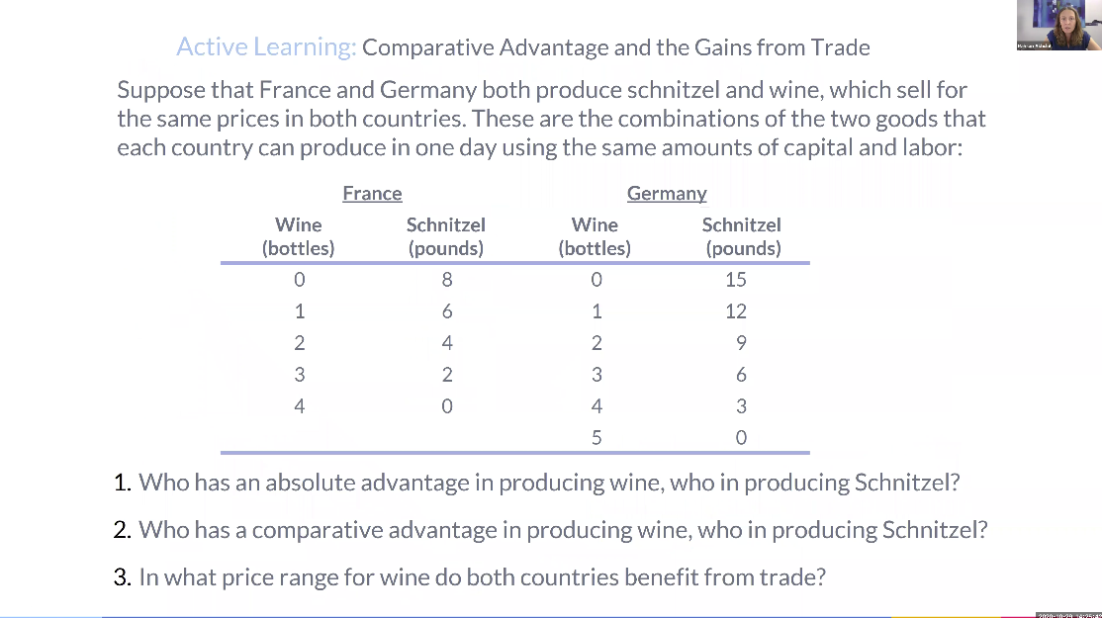

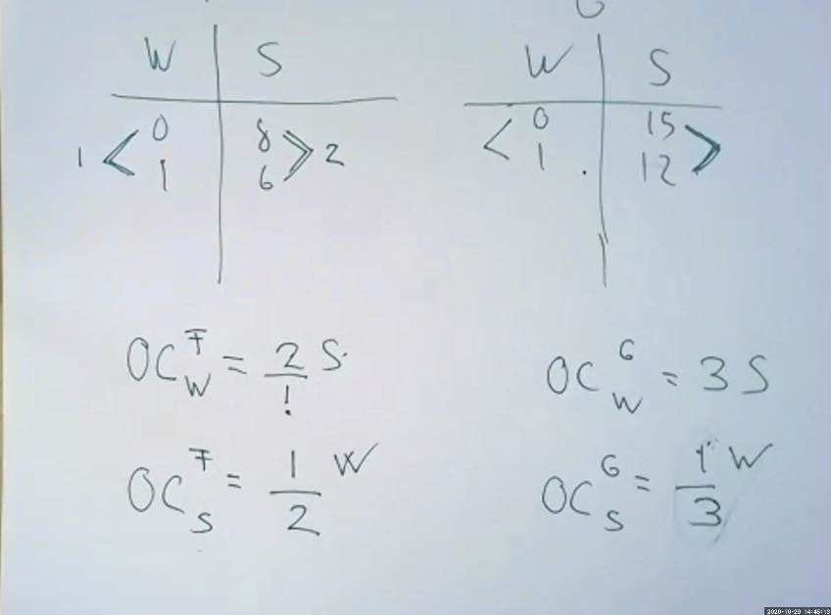

My understanding:

1. Germany has absolute advantage in both Schnitzel and wine.
2. France has comparative advantage in wine. Germany has comparative advantage in Schnitzel.
3. 2 S < Price range (wine) < 3 S

1/3 W < Price range (Schnitzel) < ½ W

If the price of wine is higher than 3 Schnitzel, Germany can produce its own wine instead of trading, and if the price is lower than 2 Schnitzel, France can produce Schnitzel instead of trading. The same is true for Price of Schnitzel.

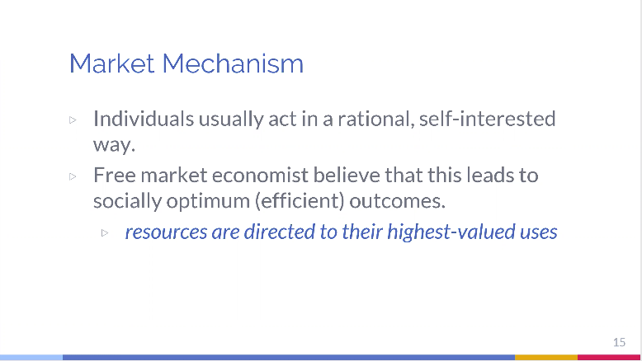

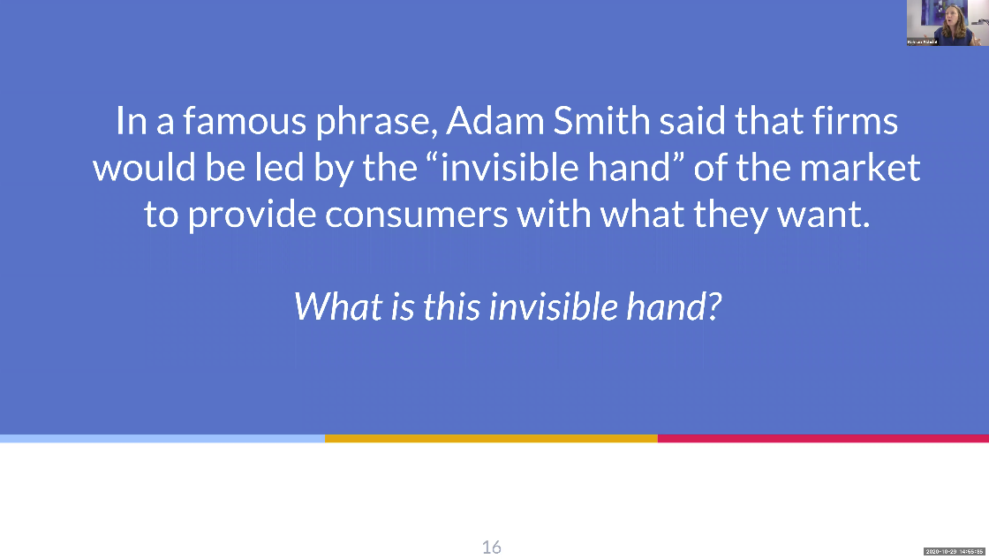

Based on supply and demand, the "invisible hand" is an image term for the capitalist model of perfect competition. The main feature of this model is private ownership. Everyone has the freedom to obtain market information and compete freely without government intervention in economic activities.

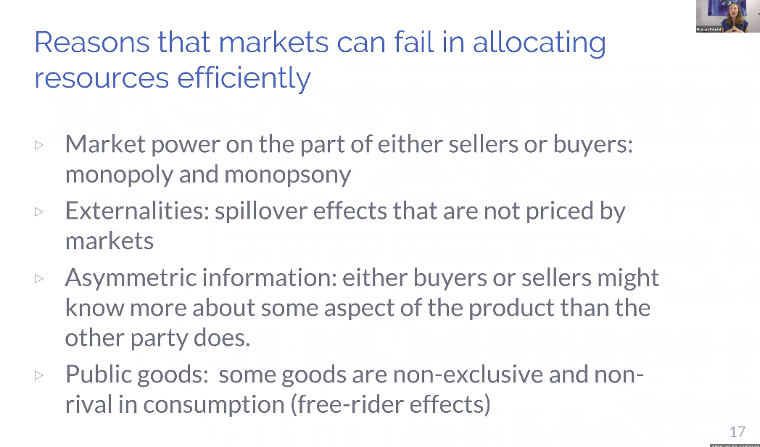

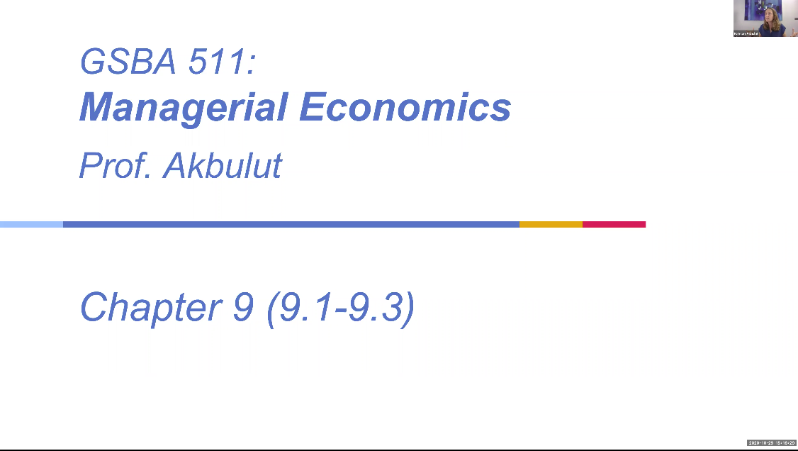

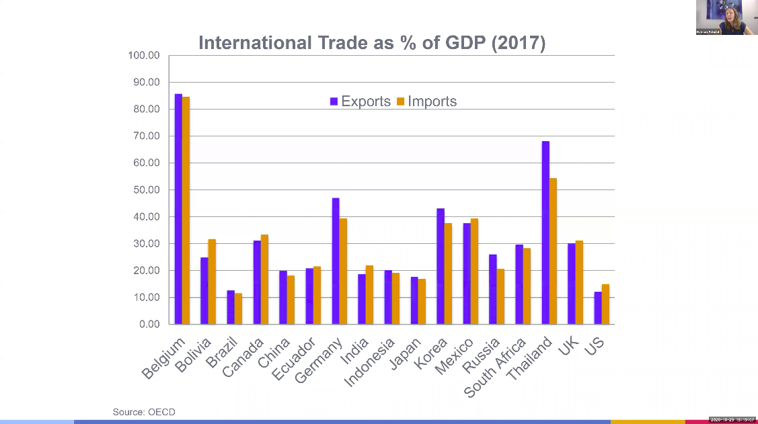

My understanding:

Some large country like US and China, they are less dependent on imports and exports and small country like Belgium are more dependent on international trade.

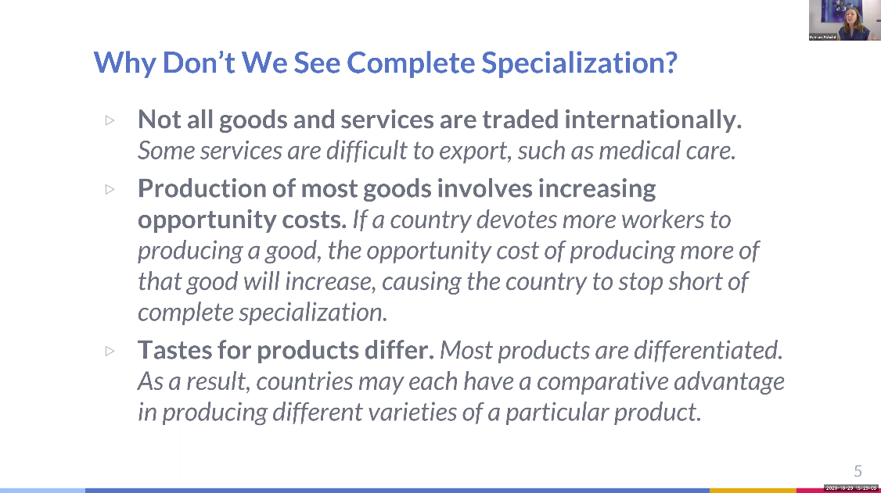

My understanding:

The main reason is the restricted flow of goods and the existence of tariff barriers, which reduce or even lose the comparative advantage to a large extent

Another important reason is that for non-economic reasons, such as political and social considerations, countries will also develop some industries without comparative advantages

Third, we may have had a comparative advantage in the past, but we have lost it later, and the cost of exit is very high, so we still have to continue production

Fourth, in order to support the development of other related industries

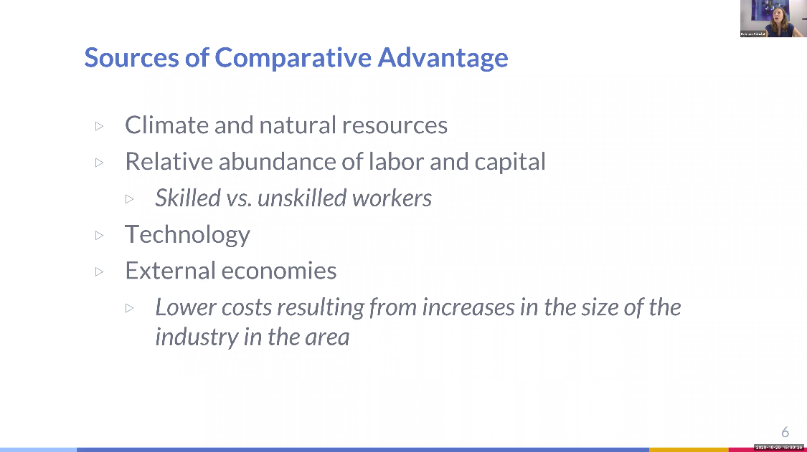

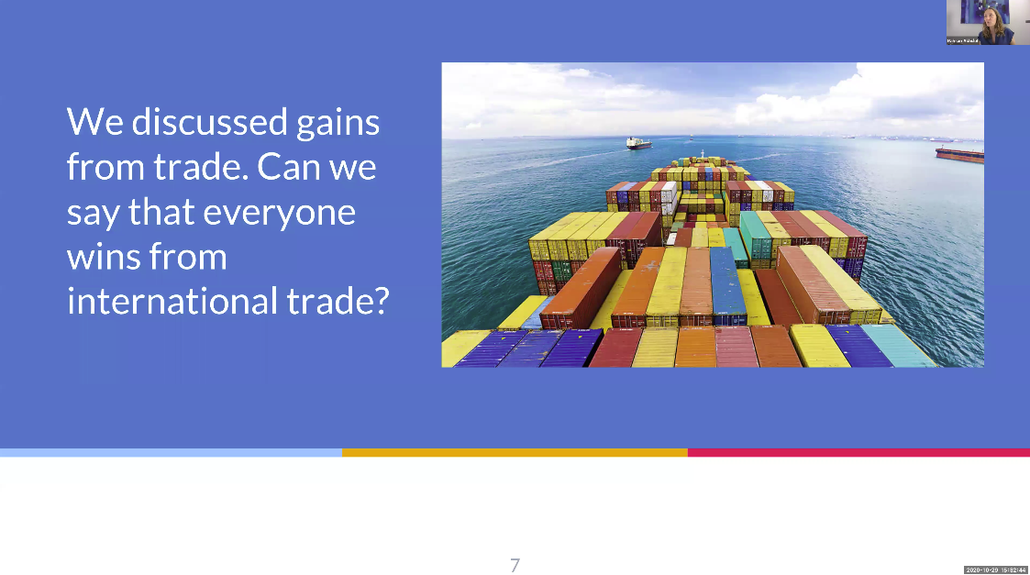

My understanding:

No, first, due to the imbalance of social and economic development within and between nation states, economic globalization has made poor countries poorer and rich countries richer, especially widening the gap between the rich and the poor. Second, economic globalization will cause the overexploitation and destruction of the global ecosystem and threaten the survival of human beings.

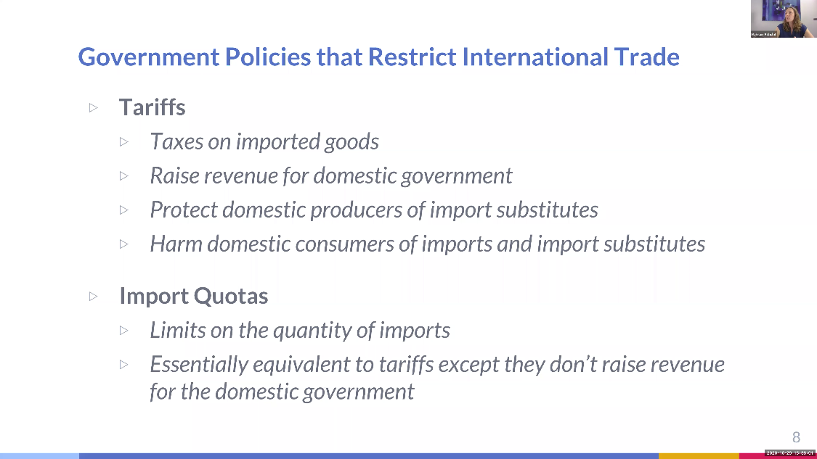

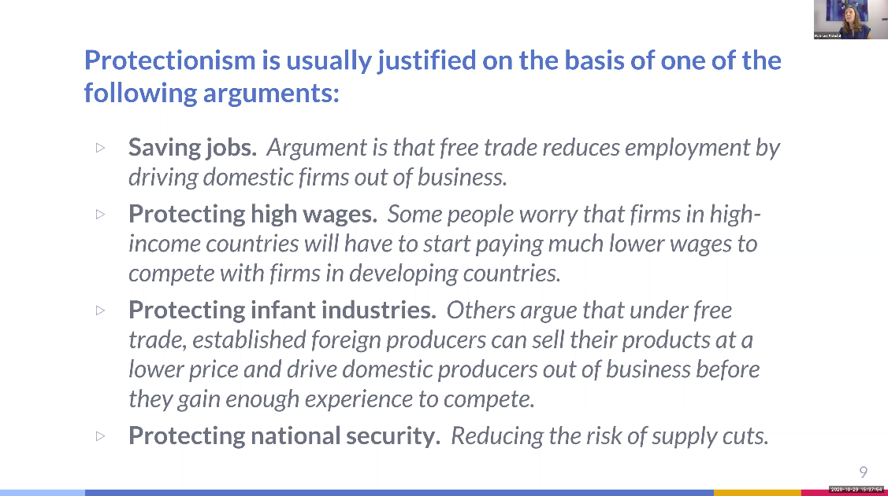

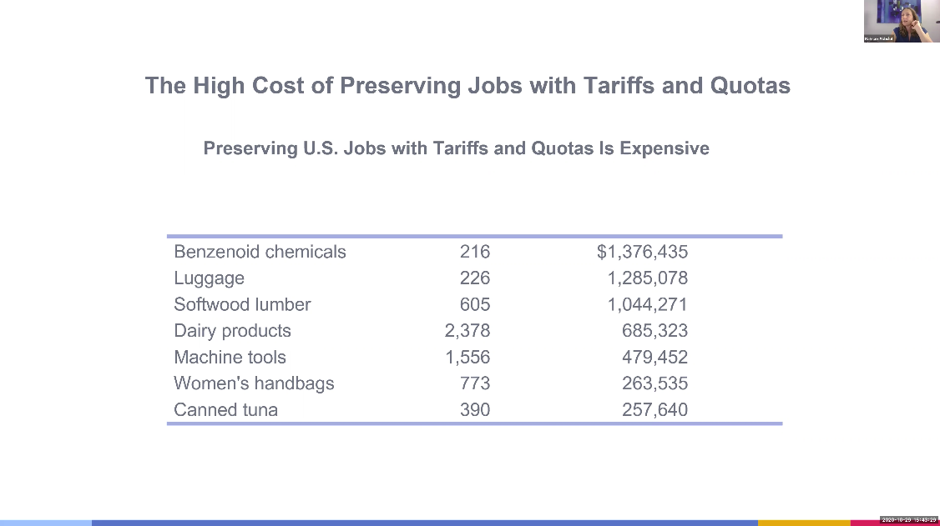

The cost is to the workers.

My understanding:

High cost of tariffs and quotas will effectively protect domestic industries and markets, improve the competitiveness of domestic commodities, increase state revenue and promote economic development.

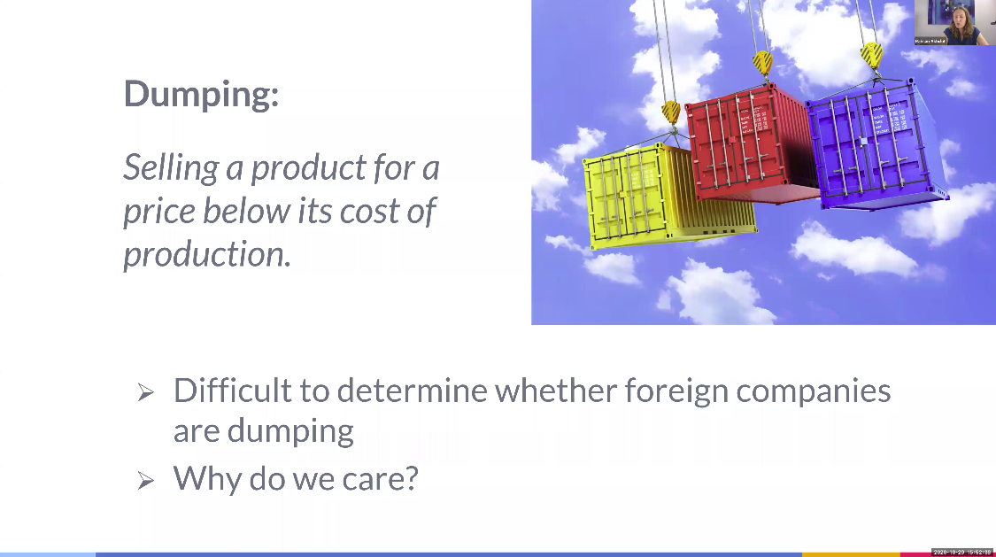

My understanding:

Dumping has many harms to destroy the market order of importing country and rob the market share and profit of importing country's enterprises. It is not conducive to the development of national industries in importing countries.

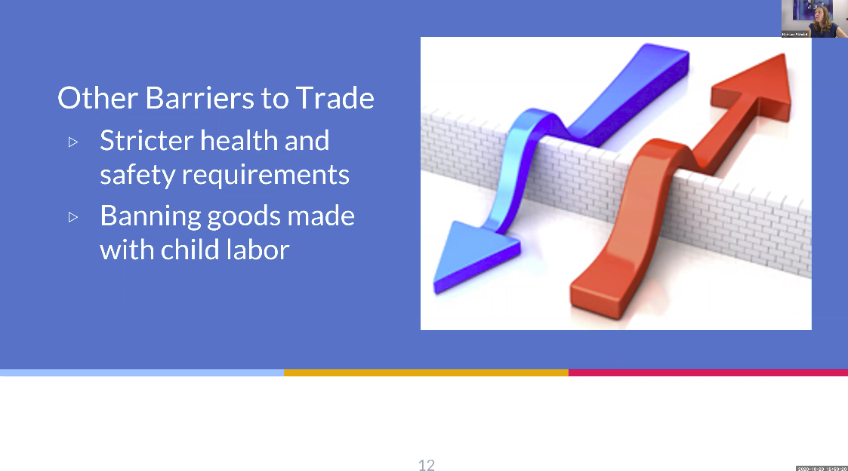

Why do we not buying goods produce by kids? what is the potential/intended consequence?

Kid should in school, getting education. If they are engaged in manual labor, their physical development will be seriously affected.

HW

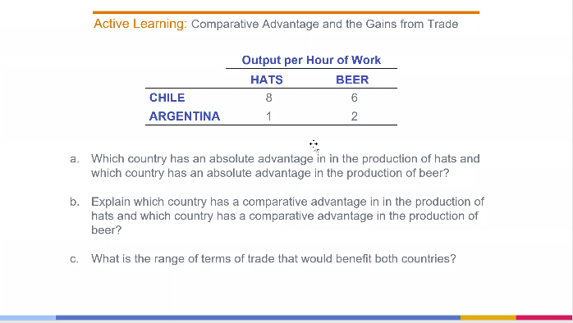

Answer:

1. Chile has absolute advantage in both hats and beers.
2. 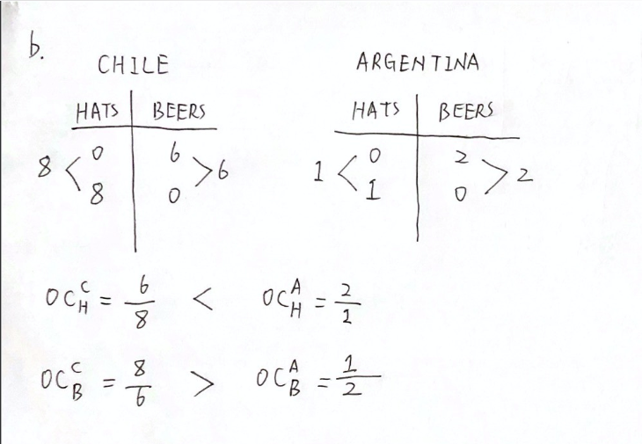

Argentina has comparative advantage in hats.

Chile has comparative advantage in beers.

1. 6/8 Beers < Price range (Hats) < 2 Beers

8/6 Hats < Price range (Beers) < 1/2 Hats

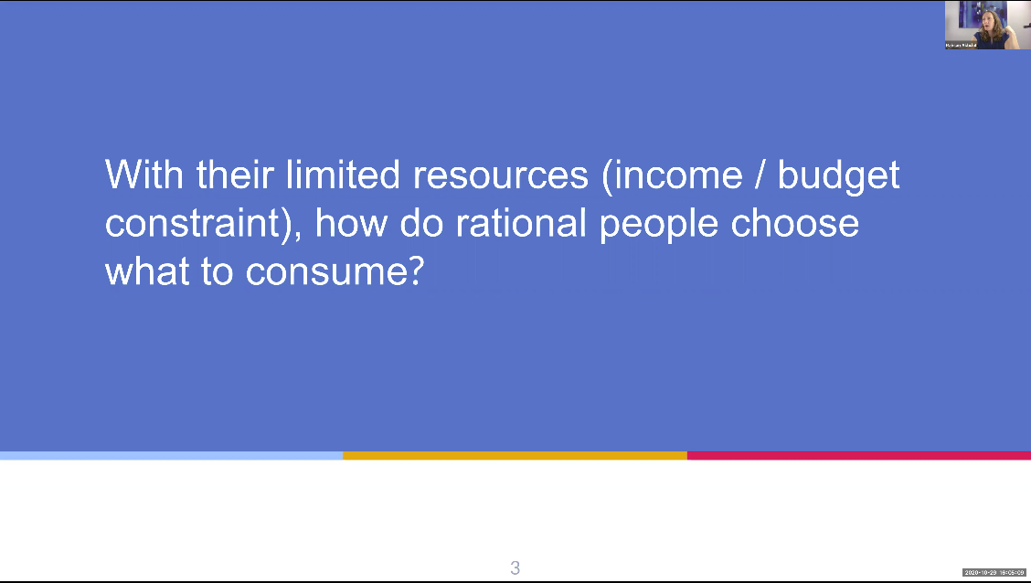

How do you make a choice when you decide how much to spend on entertainment, how much to spend on food, how are chose choices made?

Depends on preference. People will spend what they want to spend most within their budget.

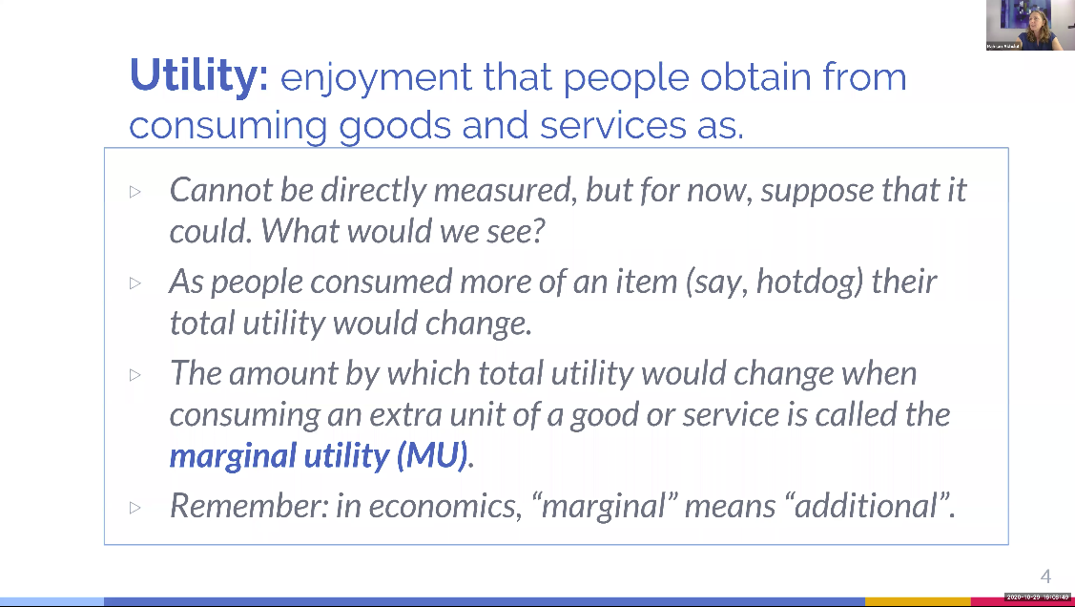

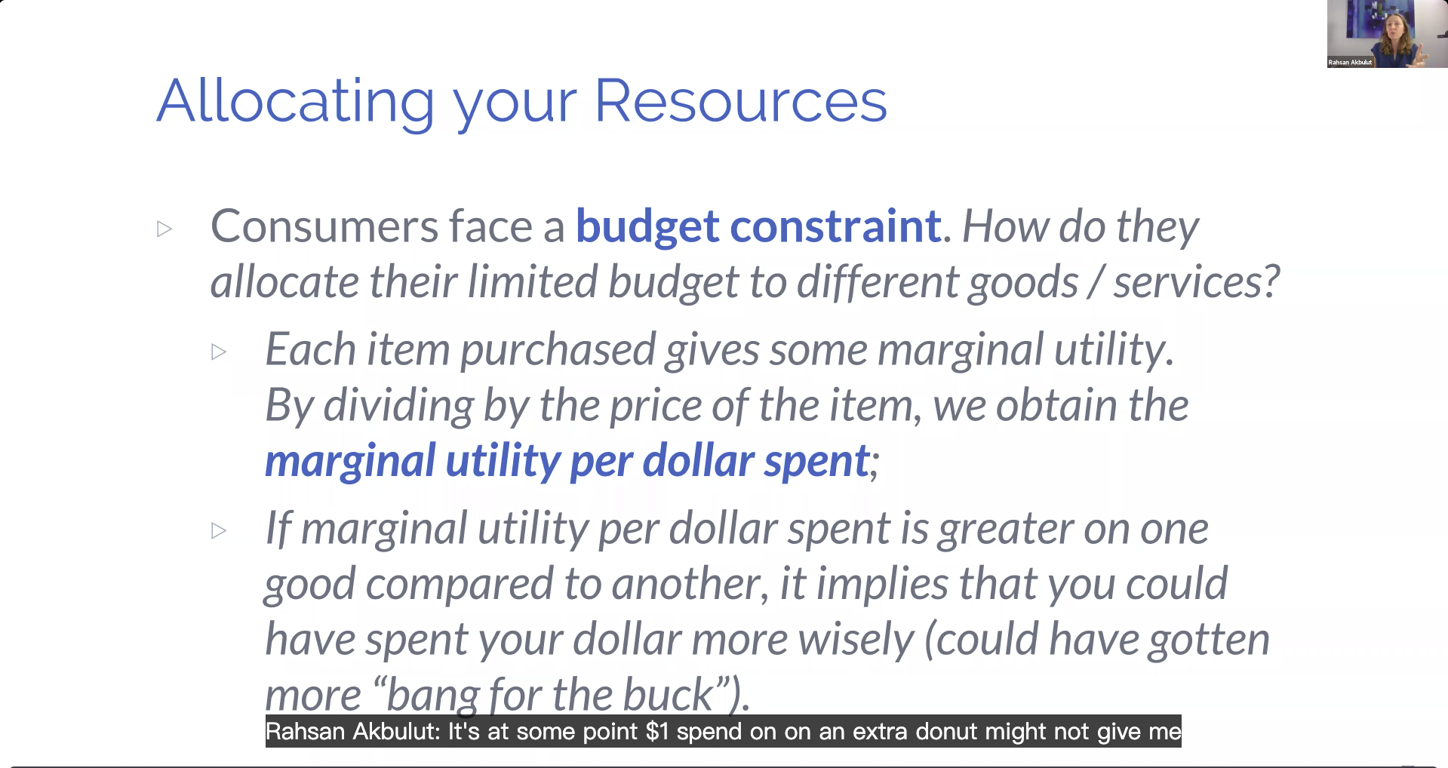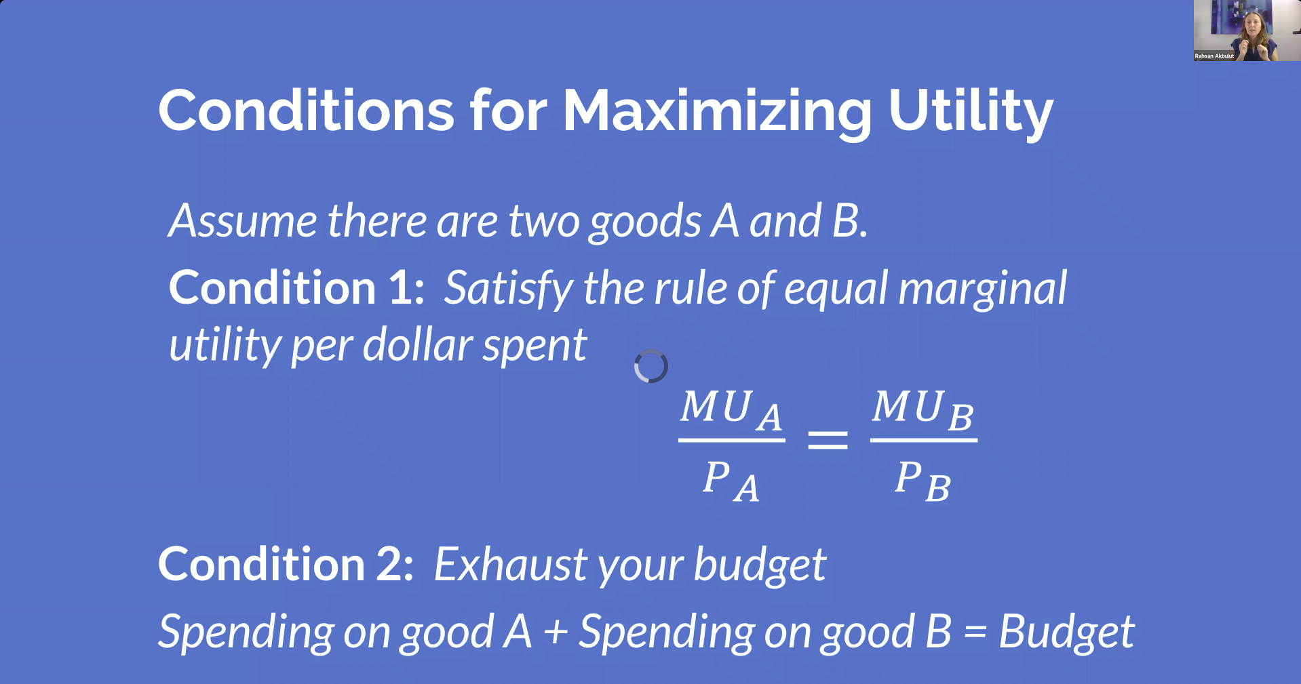

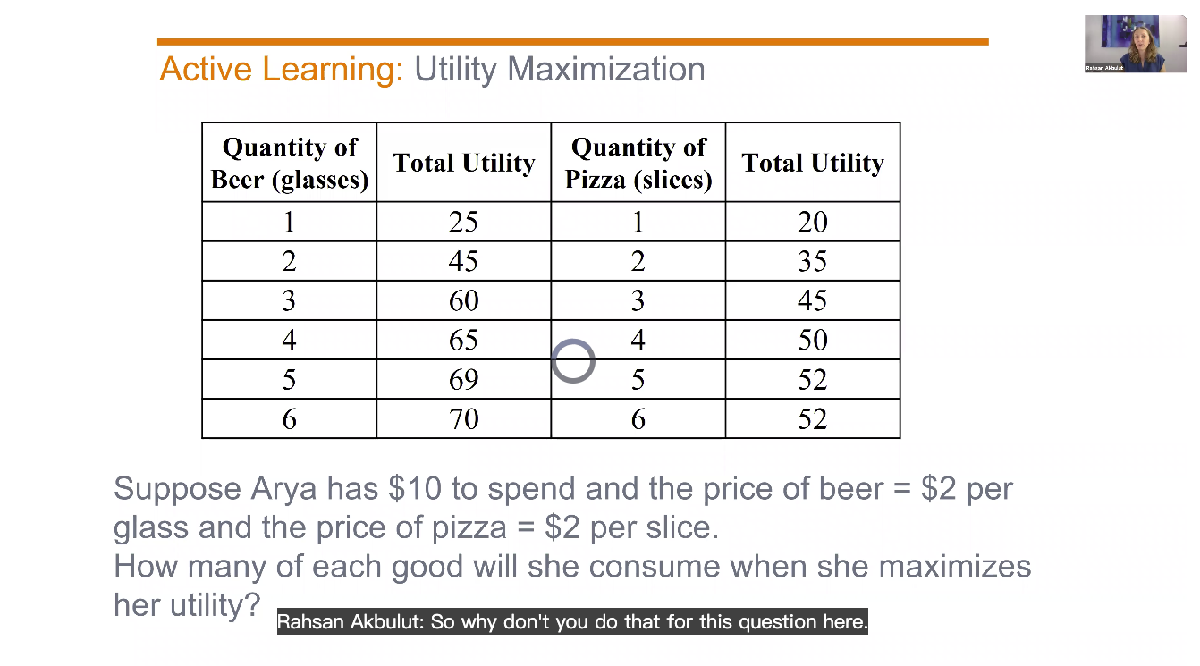

Answer: 